A000-Afr-Gabon-Kota Mbulu-ngula Reliquary Figure-early 20th c

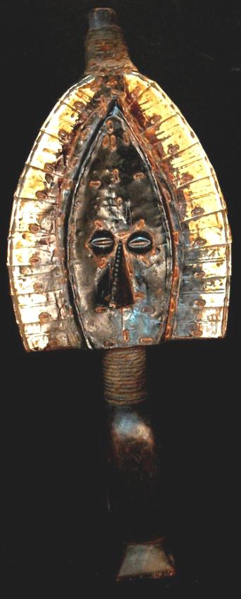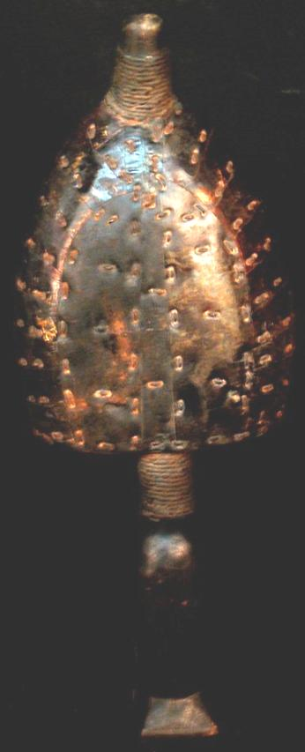

Afr-Gabon-Kota Mbulu-ngula Reliquary Figure-early 20th c

Case No.: 6

**Accession No.**

**Formal Label:** Afr-Gabon-Kota Mbulu-ngula Reliquary Figure-early 20th c

**Display Description:**

This Mahongwe reliquary was produced by a tribal group numbering only 1,000 in the northeast corner of Gabon in the Mekambo area that speaks an undocumented and threatened Bantu language (Lewis 2009). The identification of the cultural source of this reliquary was deduced by L. Perrois (1979) from a descriptive inventory of forms. This group which he identified was the only one for which there is a certainty of ethnic origin. It has been described as "Category 1, Ogival face, horizontal metal strip covering" Perrois 1987: 42). Within this category there are two sub types of which this falls into the second on the basis of its size, that is, exceeding 40 cm. high.

**LC Classification:**

**Date or Time Horizon:**

**Geographical Area:**

**Map:**

**GPS coordinates:**

**Cultural Affiliation:**

**Media:** wood, brass, natural fibers.

**Dimensions:** 16.14 in. (41 cm.) high

**Weight:** 1.25 pounds

**Condition:**

**Provenance:**

**Discussion:**

**References:**

Lewis, M. Paul (ed.), 2009. *Ethnologue: Languages of the World*, Sixteenth edition. Dallas, Tex.: SIL International. Online version: <http://www.ethnologue.com/>. [ISO 639-3](http://www.ethnologue.org/ethno_docs/introduction.asp" \l "iso_code): [mhb](http://www.sil.org/iso639-3/documentation.asp?id=mhb)

Perrois, Louis. 1987. Ancestral art of Gabon from the collections of the Barbier-Mueller Museum. Dallas: Dallas Museum of Art; Los Angeles: Los Angeles County Museum of Art.

